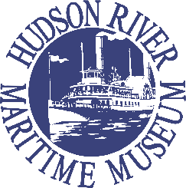

Hudson River Maritime Museum
Board Application

Thank you for your interest in serving on our Board of Trustees. Please complete this application and submit, along with your resume, to Lisa Cline, Executive Director, at lcline@hrmm.org. This application may also be completed online at www.hrmm.org. We will be in touch as the application process proceeds.

Date:

Name:

Mailing address:

Street address:

Phone:

Email address:

- Why do you want to serve on the Board of HRMM?

- What personal or professional connection do you have to the history of the Hudson River and its tributaries?

- Is there any experience or skill you will bring to your leadership role at HRMM?

- Do you presently volunteer on behalf of other community organizations? If so, please describe the relationship.

- Please list one reference who can attest to the value you can bring to HRMM. This person should be a professional or personal reference and not a family member. Please list their name, phone number and explain the context in which you know this person.

