**Fun with Semaphore!**

Before radios were invented, semaphore was way of communicating between ships with signal flags. Each letter and number was assigned a signal position. Messages were spelled out; much like Morse code was used with telegraph lines on land. To change between numerals and letters, use the numeral signal or the letter signal (J).

Using the flags provided, find a partner and see if you can spell out your name and your age. Don’t forget the numeral and letter signals! If you have time, see if you can decipher the semaphore signals at the end of this sheet.

|  |  |  |
| --- | --- | --- |
| **Meaning** | **Receive (Look)** | **Send (Do)** |
| **Rest/Space** |  |  |
| **Numerals** |  |  |
| **Error or Attention** |  |  |
| **A or 1** |  |  |
| **B or 2** |  |  |
| **C or 3**  **Also – Acknowledge or Correct** |  |  |
| **D or 4** |  |  |
| **E or 5**  **(8x = Error)** |  |  |
| **F or 6** |  |  |
| **G or 7** |  |  |
| **H or 8** |  |  |
| **I or 9** |  |  |
| **J or Letters** |  |  |
| **K or 0 (zero)**  **Also, Invitation to Transmit** |  |  |
| **L** |  |  |
| **M** |  |  |
| **N** |  |  |
| **O** |  |  |
| **P** |  |  |
| **Q** |  |  |
| **R** |  |  |
| **S** |  |  |
| **T** |  |  |
| **U** |  |  |
| **V** |  |  |
| **W** |  |  |
| **X** |  |  |
| **Y** |  |  |
| **Z** |  |  |

See if you can decipher the words below! Don’t forget about non-letter signal flags!

[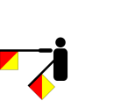](http://en.wikipedia.org/wiki/File:Semaphore_Hotel.svg)[](http://en.wikipedia.org/wiki/File:Semaphore_Uniform.svg)[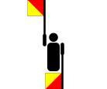](http://en.wikipedia.org/wiki/File:Semaphore_Delta.svg)[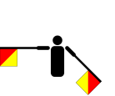](http://en.wikipedia.org/wiki/File:Semaphore_Sierra.svg)[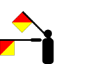](http://en.wikipedia.org/wiki/File:Semaphore_Oscar.svg)[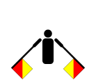](http://en.wikipedia.org/wiki/File:Semaphore_November.svg)[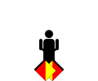](http://en.wikipedia.org/wiki/File:Semaphore_Ready.svg)[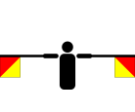](http://en.wikipedia.org/wiki/File:Semaphore_Romeo.svg)[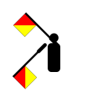](http://en.wikipedia.org/wiki/File:Semaphore_India.svg)[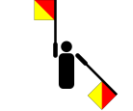](http://en.wikipedia.org/wiki/File:Semaphore_Victor.svg)[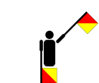](http://en.wikipedia.org/wiki/File:Semaphore_Echo.svg)[](http://en.wikipedia.org/wiki/File:Semaphore_Romeo.svg)

[](http://en.wikipedia.org/wiki/File:Semaphore_Romeo.svg) [](http://en.wikipedia.org/wiki/File:Semaphore_Oscar.svg)[](http://en.wikipedia.org/wiki/File:Semaphore_November.svg)[](http://en.wikipedia.org/wiki/File:Semaphore_Delta.svg)[](http://en.wikipedia.org/wiki/File:Semaphore_Oscar.svg)[](http://en.wikipedia.org/wiki/File:Semaphore_Uniform.svg)[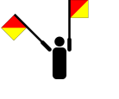](http://en.wikipedia.org/wiki/File:Semaphore_Tango.svg)[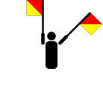](http://en.wikipedia.org/wiki/File:Semaphore_Numeric.svg)[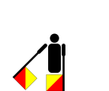](http://en.wikipedia.org/wiki/File:Semaphore_Alpha.svg)[](http://en.wikipedia.org/wiki/File:Semaphore_India.svg)[](http://en.wikipedia.org/wiki/File:Semaphore_Alpha.svg)[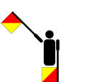](http://en.wikipedia.org/wiki/File:Semaphore_Charlie.svg)